**Book-A-Study Room**

**Deliverable #4**

October 26th, 2018

**HAXORS**

Eliza Gaudio (1554032)

Elie Sader (6128748)

Jonnie Klein Quezada (1640380)

Kevin Hirsh (1634710)

Kyle Nancoo (1441915)

**Client organization:**

Vanier College Library

**Client name:**

Haritos Kavallos

**Table of Contents**

Executive Overview…………………..……………………..…… 3

Summary description of client...……..……………….………. 4

Description of future information system..................... 4-6

Appendix 1……….………………………………..…………... 6-8

Appendix 2……………………………………………….….. 8-14

Appendix 3….………………………………….………….. 15-16

Works Cited………………………………………………….….. 17

**Executive Overview**

In this deliverable, we created different user stories based on the discussion we had with our client, Haritos, and the librarians who will also be using the booking system. We had separate meetings with both actors to get a better understanding of what each actor wants to be able to do with the system, and that helped us produce our user stories.

The description of our client, Haritos, has not changed. He is still the manager of the Vanier College Library, and you can still find information about him under the “Summary description of client” section in our deliverable, resembling the information we discussed in the previous deliverable. You still learn about his academic background and his life accomplishments, as well as other related information. Since our discussion with Haritos about his personal life, we feel that we’ve gained a better connection with him.

The narrative description of the future information system is a summary of what the client/actors would like to be able to do with the prototype we wish to implement for them. In our case, we would like to build a booking system for the study rooms at Vanier College. Based on the meeting we had with both Haritos, and the librarians, we received specific information about their interests and needs from this prototype. Throughout this section of the deliverable, we summarize and describe those points.

In Appendix 1 is where you will find all our user stories. We had to create 30 of them, all based on the actors that will be taking part in our future system. We developed our user story cards based on the meeting we had with the client. In this appendix, you’ll find scans of the actual story cards, and an explanation to describe all of them.

In Appendix 2, we test out the user stories using specific tests that we’ve learnt from this course. Each user story has 2 possible tests to verify the credibility of our system, and the information it provides. On the front of the user story card, we wrote the actual story, and on the back has both tests explained in detail. Attached to this appendix is also the photo of the user story card we included in appendix 1, with descriptions of all the others.

In Appendix 3, we had to create a user story map based on the 30 different user stories we created. In this section, we included the photos of the map that consist of all the cue cards we wrote our stories on. We also included a close up of some of them, so that it’s clear and legible.

**Summary description of client**

Our client goes by the name of Haritos Kavallos. He works at Vanier College, the institution/organization where our library booking rooms are. Haritos has accomplished quite a long list of things in such a short period of time; his CV is extremely diversified. He’s studied in many different programs, as well as been employed at many different places/positions.

To vaguely summarize Haritos’ educational/career background, he started college in 2004 and completed his DEC in Computer Science Technology in 2008. Following that, from 2008 – 2017, he spent 9 years studying to get a computer science degree, an educational degree, and a business degree. He is currently still in school at McGill, further pursuing a communications degree. He has worked as a software developer, a teaching assistant, and a tutor, all in different academic institutes. He is now currently the Learning Commons coordinator at Vanier College, which includes departments such as the library, the Tutoring and Academic Success Centre and the Science, Technology, Engineering and Mathematics Centre. He is responsible for any planning, organizing, coordination, supervision and evaluation concerning those departments.

We are working alongside him to develop our prototype system for the library’s booking rooms. The librarians keep track of information regarding the rooms, but Haritos is the manager who has all the access, so we deal with him primarily.

Working with someone for an entire semester may seem short, but it’s actually a relatively long time. Because of that, we wanted to make sure Haritos trusted us, and having a discussion with him about his personal life shows we care. After that day, we felt a change in our connection with him, and it has become easier to work with Haritos.

**Description of future information system**

Our plan, as a team, is to implement a booking system for Haritos, the librarians and students/teachers, in order to use the study rooms. The way this system would work hypothetically is that the admin, Haritos, would have access to the entire system, with privileges to the more complex and confidential data, as well as statistics (who’s booking the room, students from which program, during what times are they being booked, etc.), the librarians will be able to make changes in the system, as they are the ones in charge of keeping track of bookings, and the students/teachers will only have access to the reservation system, but no confidential data.

After meeting with our client and the librarians, we discovered a few different things that they would like to be able to do with the prototype to solve their problem. Based on that, we were able to produce user stories with them, from the information they provided to us.

The administrator, which in this case, is Haritos, wants to be able to perform 4 important actions with the reservation system. Haritos wants to be able to access some type of analytics page, because he wants to keep track of statistics. As per what he told us, he wants to be able to see what type of students are reserving the study rooms (i.e. students from which program), and he wants to be able to see during what times the rooms are being booked the most often (i.e. specific days of a certain month/specific hours in a day). As an admin, he also wants to have access to the database to be able to make changes to the actual system’s data. In other words, when, for example, a student graduates, he wants to be able to remove them from the database, that way they can no longer book a room after they’ve left the college. Lastly, he wants to be able to modify a student’s privileges, that way if they misuse the room, he can also remove them from the database, and have them not book a room again, and vice versa to give them their privileges back with good behaviour.

The librarians have more of a role for the usage of our booking system, as they are the ones that control which students book a room, and keep track of when they check in and out. We spoke to one librarian, and asked for her opinion on the implementation of a booking system; we also wanted to know what she wanted to do with this particular system. The librarians, as a whole, should be able to perform several more tasks than the admin. For starters, the librarians want to be able to add/remove a student’s reservation, in case it was a false booking, or the student changed their mind, etc. They should also be able to manage the availability of the rooms, as in, they could go into the reservation system to see which time slots are currently available, in the event that the student goes up to them the day of a potential booking, and have the librarian reserve for the student themselves. That also relates to being able to change a booking time. The librarians want to be able to modify a booking time of a specific room. Since the study rooms have a rule that states if a student shows up 15 minutes late to their booked study room, they are charged a fine and no longer have rights to that room, then the librarians requested to have a way of knowing when the time limit was surpassed, and they also want to be notified. In addition to that, the librarians mentioned that it would be nice to have a way of adding notes to a particular student’s file, that way when they book a room, they could see if they’ve ever misused it and prevent them from booking again. Lastly, since there are 4 study rooms and 1 music room, the librarians want to have a way of knowing what specific type of room was booked by the students.

Students/teachers have the same role for the reservation system. Both actors want to be able to do the same thing: reserve a study room. We worked with Haritos to develop possible things a student and/or a teacher would like to get out of a booking system for the study rooms. To begin, both students and teachers would want to be able to have access to the schedule, that way they can see which rooms are available, and see which time slots aren’t reserved. In relation to that, they’re going to want to have the right to book an actual room, either ahead of time, or on the day of their anticipated booking. Both the students and teachers would want to have access to the system via Omnivox, specifically because it’s the primary site they log in to. Both actors would see it differently, but will have the option to access the link from the school account. Furthermore, both teachers and students will be able to create their own account using school email to reserve the rooms. The difference between a student and a teacher is that a student would create a regular account, and a teacher would create a teacher account to have the opportunity to create a class booking to hold a lecture (although they still wouldn’t be able to exceed the limit amount of people per study room). Both students and teachers would want to be able to modify their account information, and they will also not have the right to modify that of another student/teacher. Lastly, both actors would want the right to cancel their reservation.

**Appendix 1**

1. As an admin, I want the analytics page to have a “demographics” graph in order to see the number of students in each program reserving study rooms
2. As an admin I want the analytics page to have a graph indicating the number of reservations each hour so that we can learn the peak times or peak periods
3. As an admin I would like to have access to the database to remove students that have graduated
4. As an admin I would like to strip or reinstate student eligibility
5. As a librarian I can add/remove students from a reservation
6. As a librarian I can manage a study rooms availability
7. As a librarian I can change the hours in which rooms can be booked
8. As a librarian I would like to be notified when a student has passed their time limit
9. As a librarian I would like to be notified 15 minutes after they are not present for their reservation
10. As a librarian I would like to see the schedule times
11. As a librarian I would like to know if a student Is not eligible to book a room
12. As a librarian I would like to have a registration system in order to see who is reserving a room
13. As a librarian I would like to have a section to add notes on a students profile to mark their behaviour
14. As a librarian I would like to have a time frame for a student to confirm a reservation in order to release unconfirmed reservations.
15. As a librarian I would like to see the type of room reserved
16. As a student I would like to see the availability of the rooms
17. As a student I would like to have a page where I can book a room
18. As a student I would like to be able to book a room as a group
19. As a student I can cancel a reservation
20. As a student I would like to be reminded by email about my reservation
21. As a student I would like to have access to the reservation system through omnivox
22. As a student I would like to add/remove group members to an existing reservation
23. As a student I would like a registration page to register an account to access the system
24. As a student I would like a profile page where I can update my student information
25. As a student I would like to see other group member emails
26. As a teacher I would like to reserve/cancel a room for my class to hold a lecture
27. As a teacher I would like to register a teacher account
28. As a teacher I would like to update my teacher information
29. As a teacher I would like to have access to the reservation system through omnivox
30. As a teacher I would like to see the availability of the rooms to properly schedule my lecture times.

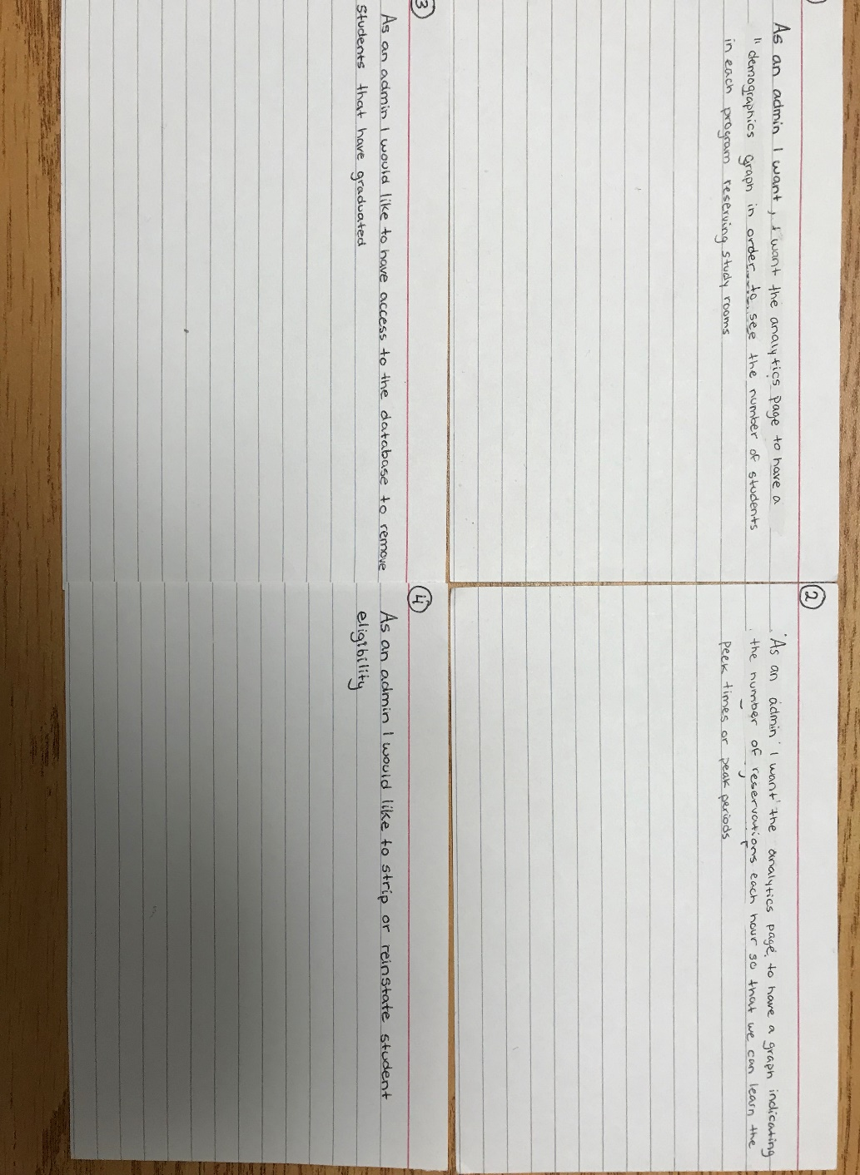

**Appendix 2**

1. Test 1

Given that the user is an admin, when the user tries to access the analytics page,

The user can gain insight on his users.

Test 2

Given that the user is not an admin, when the user tries to access the analytics page, then the user will not have access to the page and an error message will be displayed.

1. Test 1

Given that the user is an admin, when the user to access the analytics page,

The user can gain peek times on his users.

Test2

Given that the user is not an admin, when the user tries to access the analytics page, then the user will not have access to the page and an error message will be displayed.

1. Test 1

Given that the user is an admin, when the user tries to access the database, the user succeeds in removing students that have graduated.

Test 2

Given that the user is not an admin, when the user tries to access the database, then the user will not have access and an error message will be displayed.

1. Test 1

Given that the user is an admin, when the user tries to access the database, the user can strip or reinstate student eligibility.

Test 2

Given that the user is not an admin, when the user tries to access the database, then the user will not have access and an error message will be displayed.

1. Test 1

Given that the user is a librarian, when the user tries to remove/add a student to a reservation, the student will be added/removed from the reservation.

Test 2

Given that the user is a librarian, when the user tries to add a student to a reservation when it’s full, the student will not be able to be added to the reservation.

1. Test 1

Given that the user is a librarian, when the user tries to open a closed room, the room will be open in the schedule.

Test 2

Given that the user is a librarian, when the user tries to close an open room, the room will be closed in the schedule.

1. Test 1

Given that the user is a librarian, when the user tries modify a schedule time, the schedule is updated.

Test 2

Given that the user is a librarian, when I try to exceed the schedule time for the day, the schedule will not be updated and it will give an error message.

1. Test 1

Given that the user is a librarian, when a student passes their time limit, the librarian will be notified that the student has passed their time.

Test 2

Given that the user is a librarian, when a student does not pass their limit, the librarian will not receive a notification that the student has passed their time.

1. Test 1

Given that the user is a librarian, when a student is not present within 15 minutes of their reservation, the librarian will receive a notification.

Test 2

Given that the user is a librarian, when a student comes on time, the librarian will not receive a notification of the student’s tardiness.

1. Test 1

Given that the user is a librarian, when the user wants to check the schedule times, they will see the list of all the reservations of the day/week.

Test 2

Given that the user is a librarian, when the user access’s the schedule on the weekend, the user will receive an error message saying that the library is closed during the weekend.

1. Test 1

Given that the user is a librarian, when the user checks the student’s profile, the user can see if the student is not eligible and they will deny access.

Test 2

Given that the user is a librarian, when the user checks the student’s profile, the user can see if the student is eligible and they will grant access.

1. Test 1

Given that the user is a librarian, when the user wants to see if a student has registered, they can see if they have done so.

Test 2

Given that the user is a student, they will be denied access to viewing the other student’s information.

1. Test 1

Given that the user is a librarian, the user will be able to add notes on the student’s profile.

Test 2

Given that the user is a student, the user will not be able to add notes on another student’s profile.

1. Test 1

Given that the user is a librarian, the user would be able to confirm or cancel a reservation within a given time period.

Test 2

Given that the user is a librarian, when the student does not confirm or cancel the reservation within the time frame, the student’s reservation will be cancelled and the librarian will be notified about the cancellation

1. Test 1

Given that the user is a librarian, the user would be able to see the details of a reserved room.

Test 2

Given that the user is a Student, the user would be able to book a room based on type.

1. Test 1

Given that the user is a Student, the user would be able to check the schedule.

Test 2

Given that the user is a Student, the user would not be able to check the schedule for weekends and an error message will be displayed.

1. Test 1

Given that the user is a Student, the user would be able to book a room in advance.

Test 2

Given that the user is a Student, the user would not be able to book another room until the reservation has passed.

1. Test 1

Given that the user is a Student, the user would be able to create a group.

Test 2

Given that the user is a Student, the user’s members will not be able to book another room until the reservation has passed.

1. Test 1

Given that the user is a Student, the user would be able to release the reservation.

Test 2

Given that the user is a Student, when the user does not confirm or cancel a reservation, his reservation will be cancelled from the schedule.

1. Test 1

Given that the user is a Student and his email is confirmed, the user would be reminded by email about the booking.

Test 2

Given that the user is a Student and his email is not confirmed, the user would not receive any email reminding them about the booking.

1. Test 1

Given that the user is a Student enrolled at vanier, the user would be redirected to their booking through omnivox.

Test 2

Given that the user is not a Student enrolled at vanier, the user would not have access to the reservation system.

1. Test 1

Given that the user is the group leader, the user would be able to add or remove members from an existing reservation.

Test 2

Given that the user is not the group leader, the user would not be able to add or remove members from an existing reservation.

1. Test 1

Given that the user is a Student, the user would be able to create an account in order to access reservations.

Test 2

Given that the user is a Student and has an existing account, the user would not be able to create a second account to access reservations.

1. Test 1

Given that the user is a Student, the user would be able to update their own profile.

Test 2

Given that the user is a Student, the user would not be able to update another student’s profile.

1. Test 1

Given that the user is a Student and a group member, the user would be able to see the emails of the other members.

Test 2

Given that the user is a Student and is not a group member, the user would not be able to see the emails of other members in other groups.

1. Test 1

Given that the user is a Teacher, the user would be able to create a group called “class” where they could pick and choose from a list of students from their class to hold a lecture.

Test 2

Given that the user is not a Teacher, the user would not be able to create a group called “class”.

1. Test 1

Given that the user is a Teacher, the user would be able to create a teacher account with different features.

Test 2

Given that the user is a Teacher and has an existing account, the user would not be able to create another account to access reservations.

1. Test 1

Given that the user is a Teacher, the user would be able to update their profile information.

Test 2

Given that the user is a Teacher, the user would not be able to update another teacher’s profile information.

1. Test 1

Given that the user is a Teacher employed at vanier, the user would be redirected to their booking through omnivox.

Test 2

Given that the user is a Teacher not employed at vanier, the user would not have access to the reservation system.

1. Test 1

Given that the user is a Teacher, the user would be able to check the schedule.

Test 2

Given that the user is a Teacher, the user would not be able to check the schedule for weekends and an error message will be displayed.

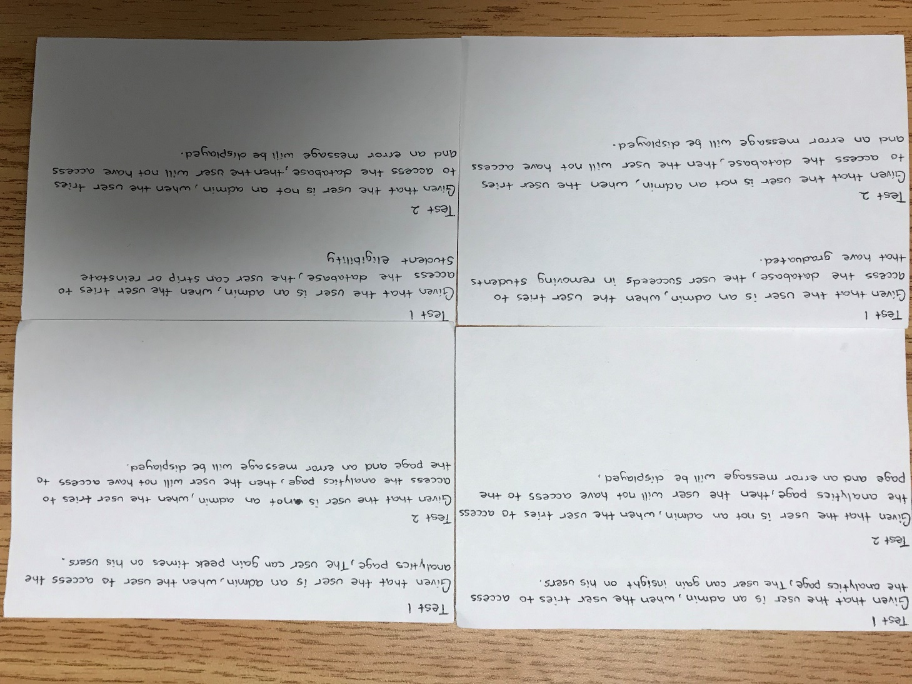

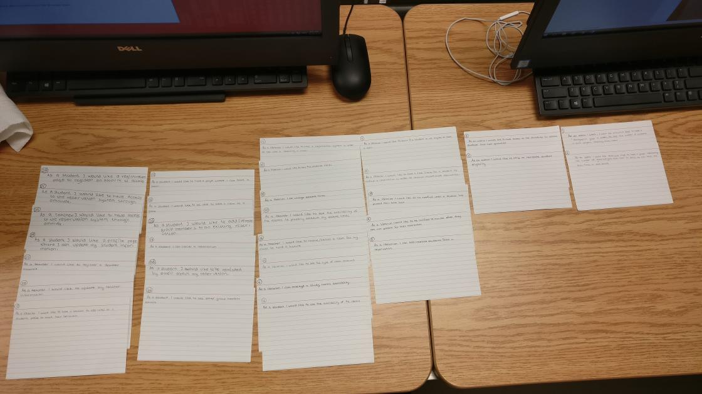**Appendix 3**

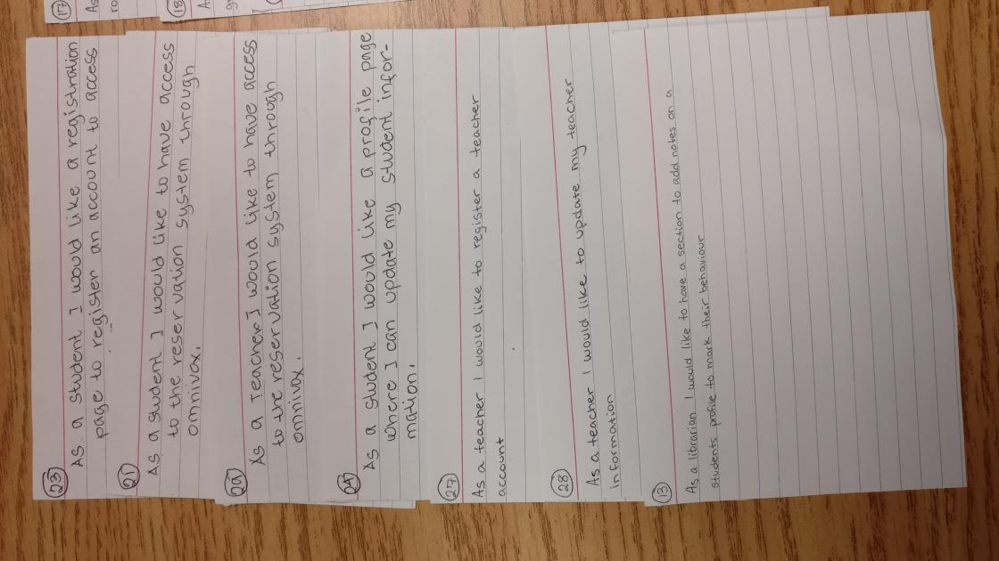

**Works Cited**

- No references were used throughout this deliverable.